# COMP1003 Maths Worksheet 2

1. A := { (-x)2 : x in **Z** } = ? [list the first 5 smallest elements only ]

Z is {0, -1, 1, -2, 2, -3, 3, …}

The squares, (-x)2 for x in Z are A = {0, 1, 4, 9, 16, … } (duplicates don’t count)

1. { -x : x in A / { 2y + 1 : y in **Z** } } = ? [ use A from task 1]

The set { 2y + 1 : y in **Z** } is the same as {1, 3, 5, 7, … , -1, -3, -5, … } ie the odd Integers

A / { 2y + 1 : y in **Z** } would then be the set of squares without the odd ones, ie the even squares. Howver, note thet the question asks for the negative values. Therefore the answer is

{ 0, -4, -16, -36, … }

1. For A := {1,2,7} , B := {7,8}, U = {0,1,2,3,4,7,8} compute the union and intersection of A and B, the differences B\A, A\B, the symmetric difference between A and B and the complement of A and with respect to U. Also compute the power set of A.

Union of A and B = {1,2,7,8}

Intersection of A and B = {7}

B\A = {8}

A\B = {1,2}

Symmetric difference of A and B = {1,2,8}

Complement of A wrt U = {0,3,4,8}

Powerset of A = { {}, {1}, {2}, {7}, {1,2}, {1,7}, {2,7}, {1,2,7}}

1. Simplify using the Set algebra, where A’ means the complement of A relative to some universe U:

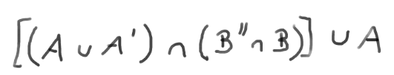

Denote union as v and intersection as ^

Then AvA’ = U , B’’=(B’)’ = B [the complement of the complement of B is B]

Then (B’’^B) = B^B = B

Therefore the equation simplifies to

[ U ^ B ] v A

But U^B is the same as B , because U contains all elements of B

Therefore we can further simplify the expression to

[ U ^ B ] v A = B v A

This cannot be further simplified because we don’t know what A and B are.

1. Using mathematical induction, prove that the sum of the first n odd numbers in **N** equals n2. This means for all n holds 1 + 3 + 5 …. + (2n-1) = n2

For example: for n=3 we have 1+3+5 = 9 , for n=4 we have 1+3+5+7=16 , and so on.

Step 1: The square of 1 is 1; therefore the statement holds for n=1

Step 2: Assume the statement S(n) = 1 + 3 + 5 …. + (2n-1) = n2  holds for some n

Then S(n+1) = 1 + 3 + 5 …. + (2(n+1)-1) = 1 + 3 + 5 …. + (2n+1)

= 1 + 3 + 5 …. + (2n-1) + (2n+1)

= n2 + (2n+1) (by induction assumption)

= (n+1)2

This now is the statement for n+1

Step 1 and 2 imply that the statement must hold for all n

1. For A = {1,2,blue} compute the Cartesian product of A with itself.

{ (1,1), (1,2), (1, blue), (2,1), (2,2), (2,blue), (blue,1), (blue,2), (blue, blue) }

1. For f : {-3,-2,-1,0,1,2,3} 🡪 **R** f(x) = x*x determine what the domain, co-domain and range are. Is the function injective, surjective or bijective. If it is bijective what is its reverse function?

The domain is the set of values that is mapped, ie {-3,-2,-1,0,1,2,3}

The co-domain by definition of the function is R

Not all elements in R are image of an element of the domain under f. Therefore the range is smaller than R. It is the set {0,3,4,9}, ie th set of images of the domain in the co-domain.

The function is not injective because some x map to the same y. It is not surjective because not all x in the co-domain are an image of some x in the domain under the operation of f. f therefore cannot be bijective and an inverse cannot exist.

1. Plot the graph of the function f(x) = 2 abs(x) – 1

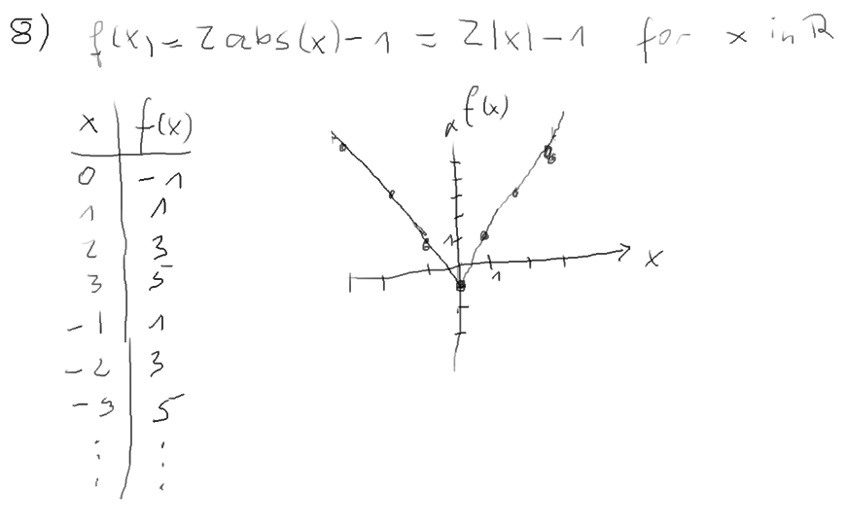

1. Determine if the >= (larger or equal) and != (not equal) relations on R are reflexive, transitive or symmetric.

Note: The question should have stated that we consider the usual ‘larger or equal’ and ‘not equal’ relations of N, Z or the real numbers. If not said explicitlet this is either implied or should be further analysed (ie any problems with this natural assumption should be worked out – however, there are none).

Reflexivity: xRx is true for all x, which is true for x>=x but false for x!=x

Symmetry: xRy implies yRx for all x, y, which is false for x>=y (example 3>=2 does not imply 2>=3) but true for !=, if x != y than apparently also y!=x (example 3 is not equal to 2, and 2 is also not equal to 3).

Transitivity if xRy and yRz then xRz for all x, y, z:

True for >= (if y is larger or equal to x and z is larger or equal to y than z must be at least as much larger than x as y is.

False for != because 2!=3 and 3!=2 does not imply that 2!=2 (note that z=x=2 and y=3 in this example)

1. Define some equivalence relation on the set of all strings over {a,b,c,d,e}. What are the equivalence classes

There are many possibilities, the most obvious one of a Relation R are strings that start with the same character. Two strings x,y satisfy the relation R (or are “in it”) if they start with the same character, written as xRy

We have to check the axioms of equivalence relations

Reflexivity: xRx : ok, because if a string starts with a certain character then it starts with that character and therefore satisfies the defining condition.

Symmetry: xRy implies yRx; ok because if xRy holds, x and y start with the same character, but the same obviously then holds for yRx as well. Order of comparison does not matter for this Relation.

Transitivity: if xRy and yRz then x, y and z must all start with the same character, and therefore xRz must satisfy the Relation.

The equivalence classes are the sets of all strings made of {a,b,c,d,e} that start with the same character

A = {a,ab,ac,aa,aaacde, …}

B = {bbb,b,bcde,bee, ….}

C={…} , D={…}, E={…}

There are 5 equivalence classes

1. Define some order relation on the set of strings.

The usual dictionary order a<aa<ab<aaa<abc<b<bb<…<z<za<zzz etc

Note: For simplicity we assume low caps strings only

We have to prove the axioms of an order relation hold

… left as an exercise.

This is a total order, all strings can be arranged on a single line of comparisons.

Can somebody come up with a partial ordering only?